CHAPTER 6: The mysterious universe

Worksheet 6.3

Star life cycles
Answers
1. The following diagram shows the evolutionary sequence of stars of different masses. Match each of the images, A–J, with the events listed in the table below. These events are randomly listed.
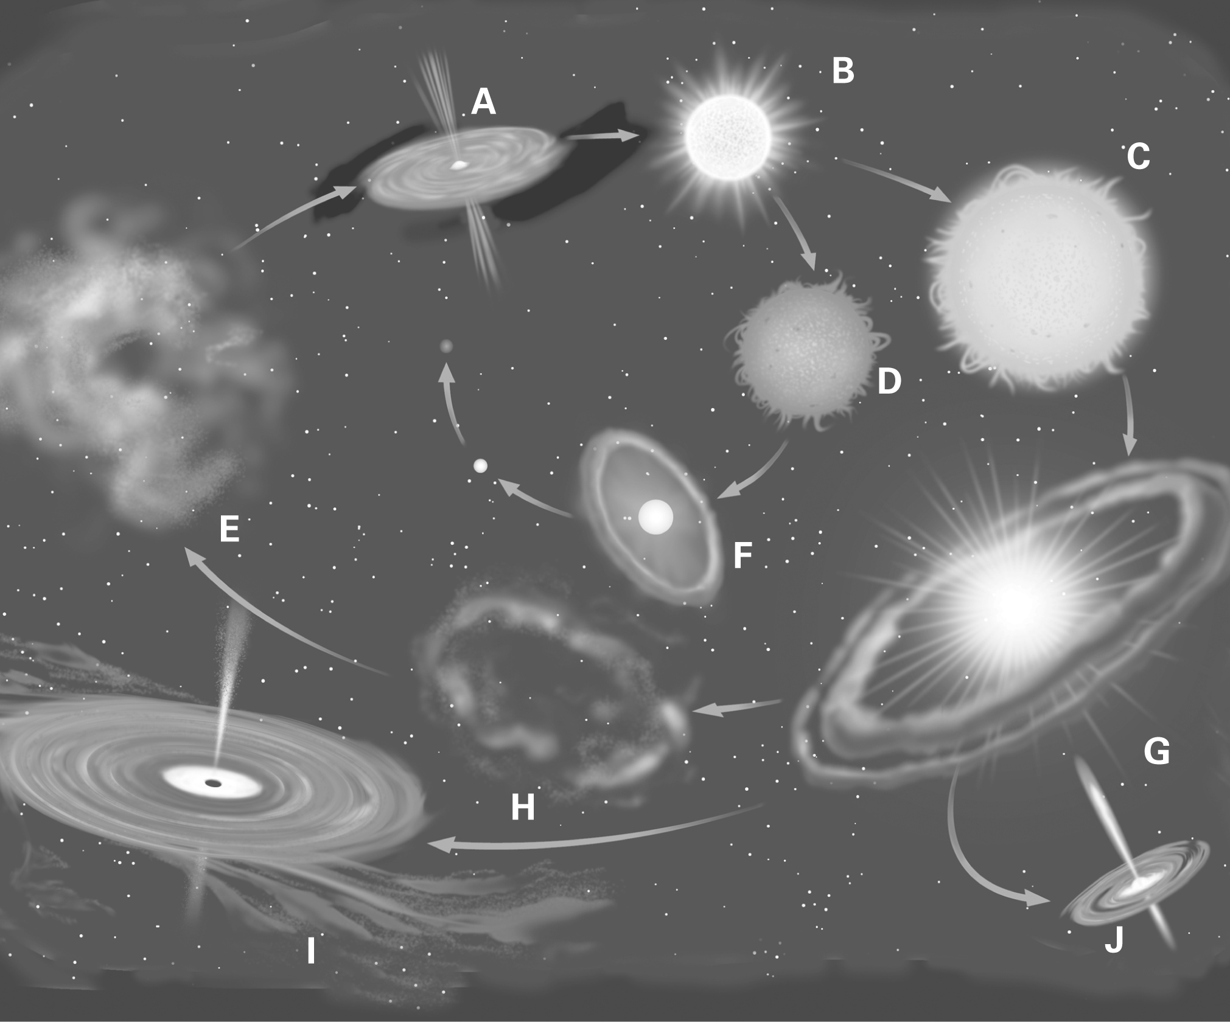

Event | Letter
Star forms and begins to shine. | B
Black hole forms from a red super giant explosion (supernova). | I
Pulsar (neutron star) forms. | J
Red giant star forms from a main sequence star. | D
White dwarf forms at the core of a red giant star. | F
Supernova forms from a red super giant. | G
Protostar forms. | A
Red super giant forms from stars heavier than our sun. | C
Large nebula forms as gravity pulls dust and gases together. | E
Small planetary nebula formed after supernova event. | H
CHAPTER 6: The mysterious universe

Worksheet 6.3

Page 2

2. Read the following text and answer the questions below.
Red giants
Stars that have a mass between one solar mass and eight solar masses will evolve into red giant stars. Betelgeuse in the Orion constellation is a red giant star. During their lives, stars like our sun, fuse hydrogen atoms together to form helium. Since helium is denser than hydrogen, the helium that forms sinks to the core of the star. The star ‘burns’ the hydrogen in the shell that surrounds this core. When the amount of helium in the star reaches about 12%, the core collapses inwards under gravity leading to intense heating. The heat causes the outer layers of the star to expand outwards. The star can swell to one hundred times its original size. The surface of these giant stars begins to cool so that the star now shines with a red light.
(a) Define the term ‘one solar mass’.
One solar mass is the mass of our sun.

(b) Explain why helium is more dense than hydrogen.
Helium has a heavier nucleus (2 protons and 2 neutrons) than hydrogen (1 proton).

(c) Describe the consequences of the gravitational collapse of the star’s core.
The core of helium collapses due to the inward pull of gravity, resulting in rapid heating. This intense heat then causes the expansion of the hydrogen shell outwards, producing a large red giant star.

